Mohammad Al Ebedan

ECE351-52

Lab 2

Sep 13, 2021

**Introduction:** We introduced user-defined functions in Python and utilized this feature to demonstrate various signal operations including time shifting, time scaling, time reversal, signal addition, and discrete differentiation.

**Part 1:**

**Task2:**

In this part, we created your own function titledfunc1 that implements the function y = cos(t) using numpy.cos() and plot the function from 0 ≤ t ≤ 10s with small enough step sizes to achieve a curve of sufficient resolution. We got the following graph:

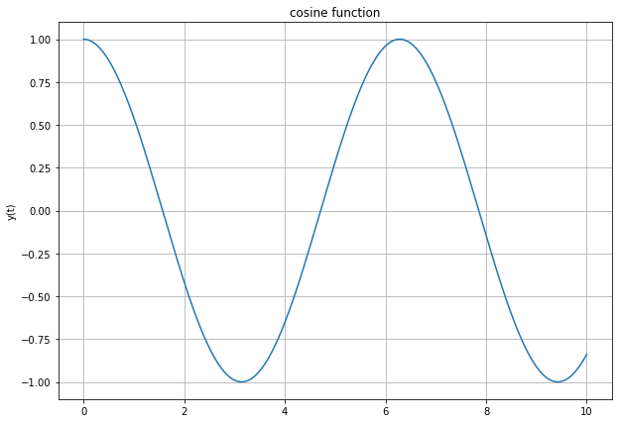

**Part 2:**

**Task1:**

We derived an equation to model the function in a given figure using step and ramp functions. The derived equation:

$$f\left(t\right)=r\left(t\right)-r\left(t-3\right)+5u\left(t-3\right)-2u\left(t-6\right)-2r(t-6)$$

**Task2:**

We created two user-defined functions, one implementing a step function and the other a ramp function. We got the following plot:

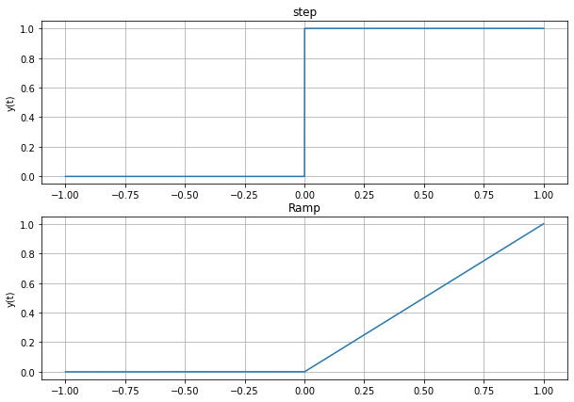

**Task3:**

We created a user-defined function to implement the derived equation in task1. The result is in the next plot:

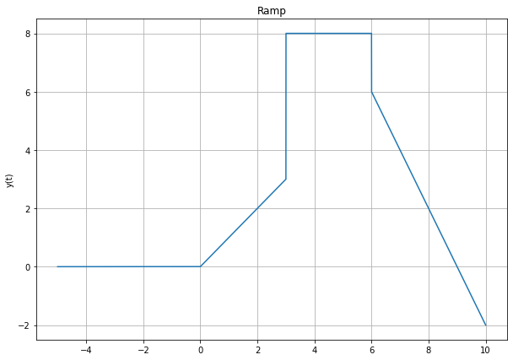

**Part 3:**

**Task1:**

We applied time reversal to f(t) to get:

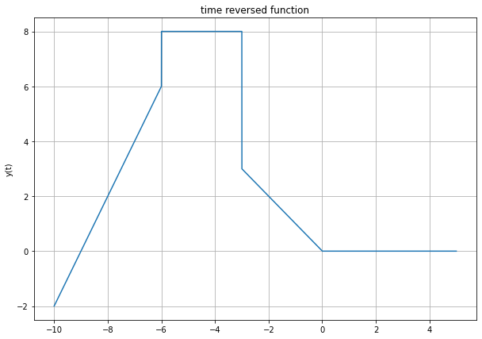

**Task2:**

We applied time shift operation to f(t) to get:

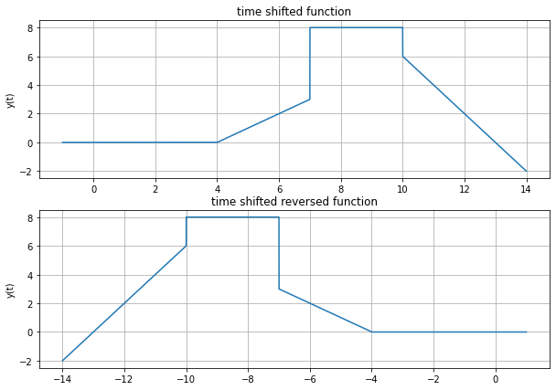

**Task3:**  
We applied time scale operation to f(t) to get:

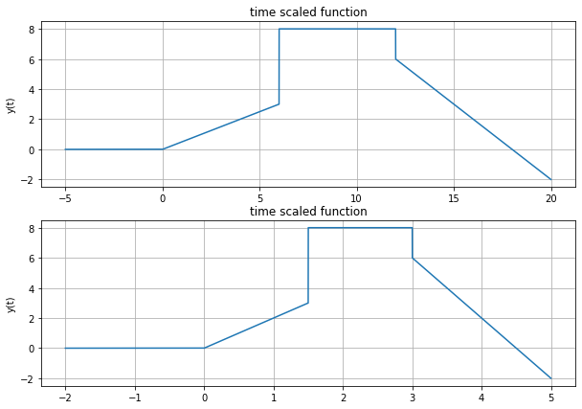

**Task4:**

We plot by hand the derivative (with respect to time) of the equation f(t)

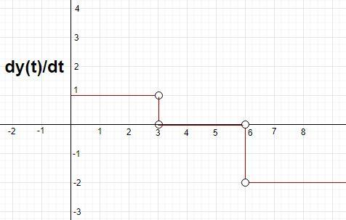

**Task5:**

Using the numpy.diff() function, we plot the derivative of your user-defined function with respect to time:  
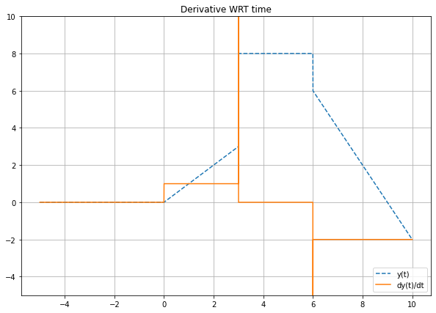

**Questions:**

**Are the plots from Part 3 Task 4 and Part 3 Task 5 identical? Is it possible for them to match? Explain why or why not.**

No, they'er not identical because when spyder diffrentiates the step funtion f(t) as impulse function and draws the derivative according to that.

**How does the correlation between the two plots (from Part 3 Task 4 and Part 3 Task 5) change if you were to change the step size within the time variable in Task 5? Explain why this happens.**

If we use a larger step size the plot will change because larger step size causes less accuracy. The step will have large slope and the impulse will be delta impulse.

**Leave any feedback on the clarity of lab tasks, expectations, and deliverables.**

Personally, I get overwhelmed because of how much we are expected to know about using Python and LATEX. However, here I am, after putting so much time and effort in learning how to use them, feeling more comfortable with this lab.

**Conclusion:**

Throughout this lab, we learned how to use user-defined functions and how to properly apply time reverse, time shift, and time scale operations and how to adjust the graph domain so it fits the changes due to the corresponding operation. In addition to that, we went over the differentiation of the ramp and step functions.